Zebra Setup Utilities Installation Instructions
The printer driver needed in this document can be downloaded using the following link:
ftp://edc-aim.com/pub/utils/Zebra/Setup_ZSU_100557.exe
1). Install Zebra Setup Utilities, locate the installer (Setup_ZSU_100557.exe)
2). Double click on the installer to launch it
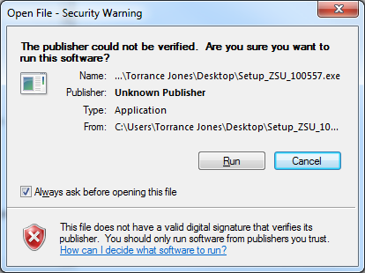
3). Click “Run”
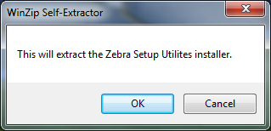
4). Click “OK”
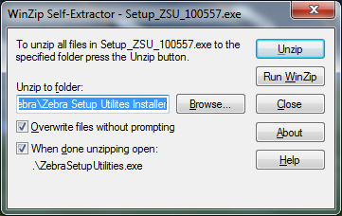
5). Click “Unzip”
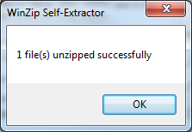
6). Click ”OK”
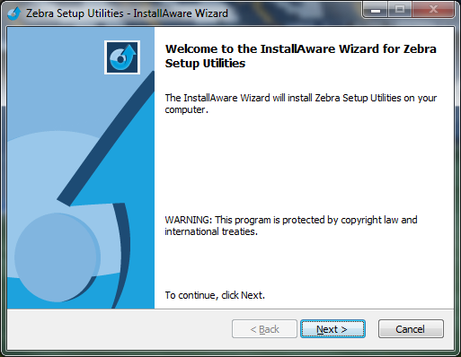
7). Click “Next”
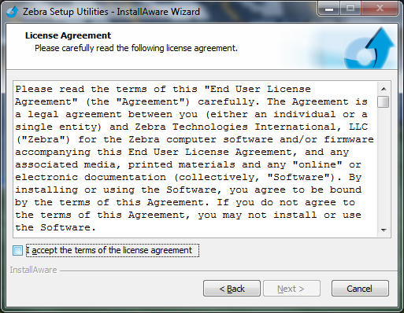
8). Check the box for “I agree” and click “Next”
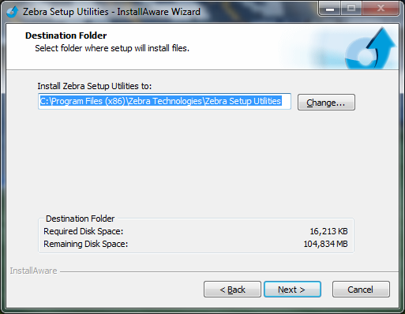
9). Set the installation location and Click “Next”
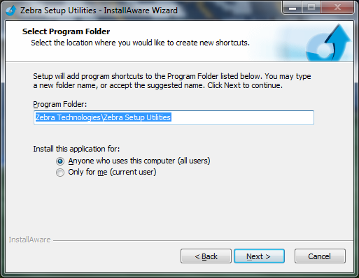
10). Click “Next”
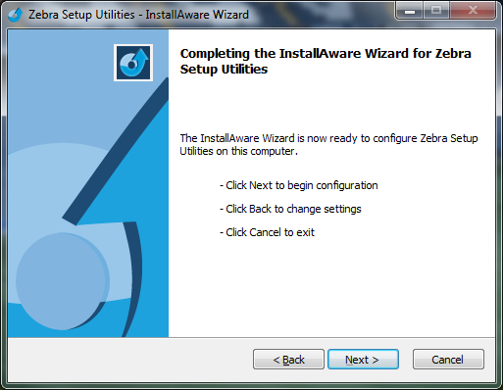
11). Click “Next”
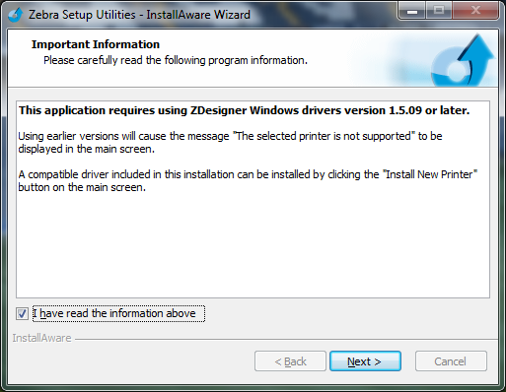
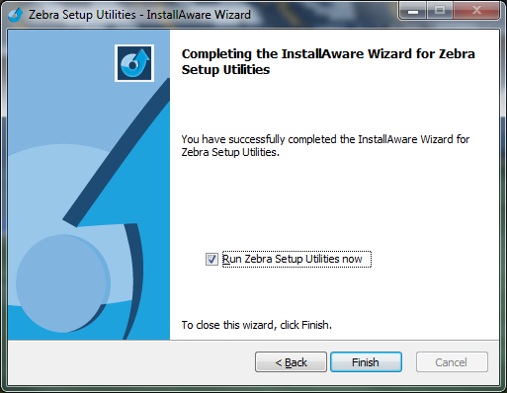
12). Check the box and click “Next”

13). Click “Finish”, installation complete

