Zebra GK420T Hangtag Setup Instructions
Required Files:
a). Zebra GK420t Printer with Network port
b). Hangtag Media (thermal coated, fan folded)
c). RJ-45 Ethernet cable (network cable)
d). Zebra Setup Utilities v. 1.0.0.557 or higher
e). Zebra Setup Utilities Installation Instructions
f). Zebra Net Bridge Enterprise v1.2.6 or higher
g). Zebra Net Bridge Enterprise Installation Instructions
Additional drivers and user manuals can be downloaded at:
http://www.zebra.com/id/zebra/na/en/index/products/printers/desktop/gk420t.html
1). Setup the physical components of the printer
a). Unpack printer
b). Plug printer into AC/Adapter, power source
c). Plug printer into an active network jack using RJ45 network cable
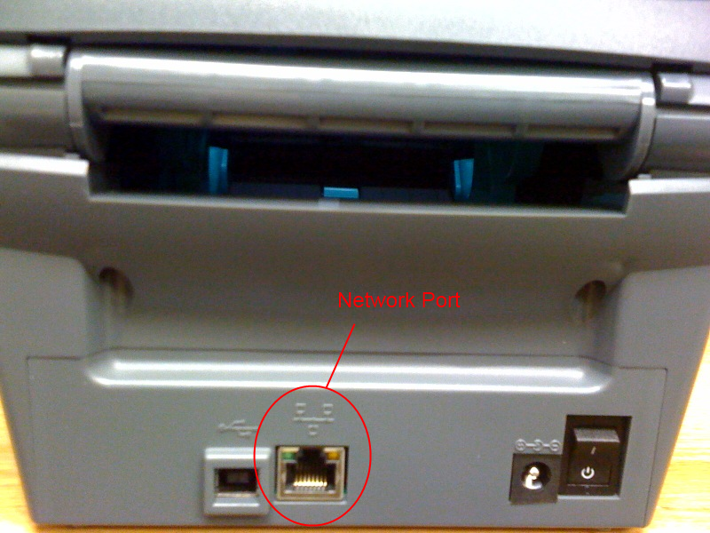
d). Open printer by pressing the green latches on the left and right side of the unit
e). Adjust the paper holder by turning the adjustment knob until the stock can be fed into the printer
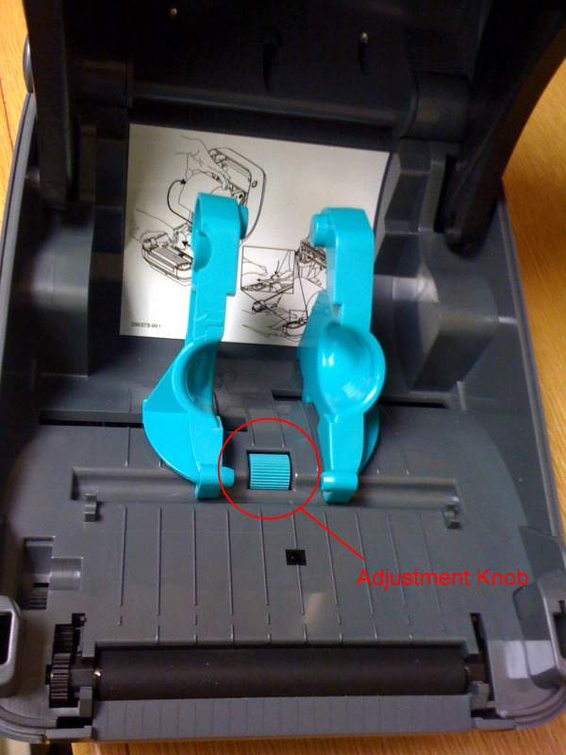
f). Load hangtag stock into the printer
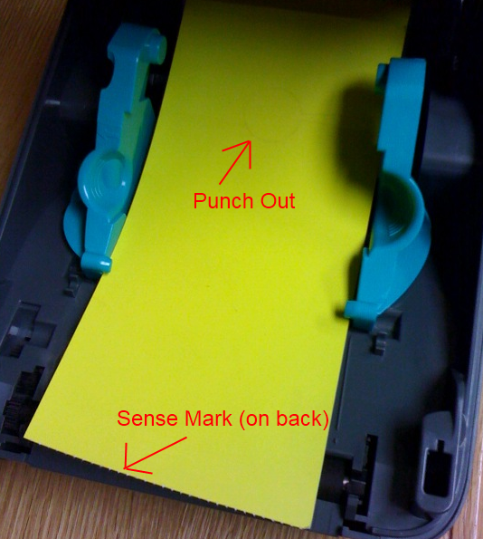
g). Close printer lid, press down to be sure the lid latches engage
h). Turn printer on with toggle switch on back of printer, wait 10 seconds for printer to power on.
2). Install Zebra Net Bridge Enterprise (if not already installed)
See “Zebra Net Installation Instructions” for more details. This software is only needed to obtain the IP Address of the printer.
3). Obtain the network IP address of the Gk420t printer
a). Run Zebra Net Bridge by clicking the Zebra Net Bridge shortcut
b). If prompted to activate product, click “Cancel”
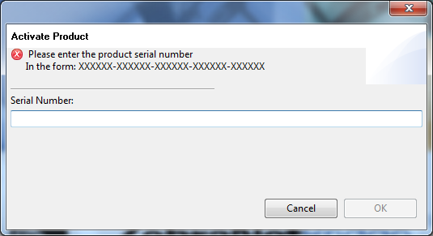
c). Expand “Searches” and “Local Search” to obtain a listing of Zebra printers located on the same network subnet.
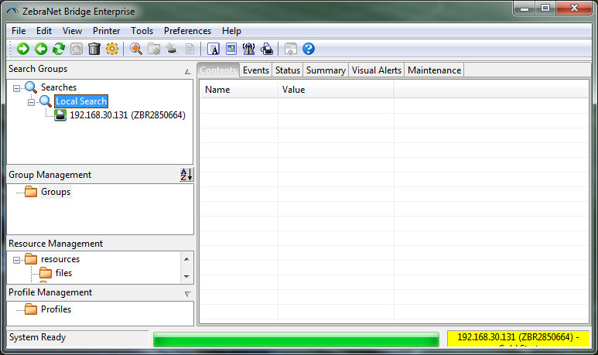
d). If the printer cannot be found using Zebra Net Bridge Enterprise then contact your network administrator to assist in locating the IP address of the printer. By default, the printer is setup to use DHCP and will automatically get an IP address from your network.
e). Additional Information:
You may also be able to determine the IP address of the printer by using the MAC address on the bottom of the printer, or by doing the “one flash” label print sequence. See the Gk420t User’s Manual for more details.
4). Configure the Zebra Gk420t Network Settings
a). Open a web browser and browse to http://xxx.xxx.xxx.xxx (where xxx.xxx.xxx.xxx is the IP address of the printer).
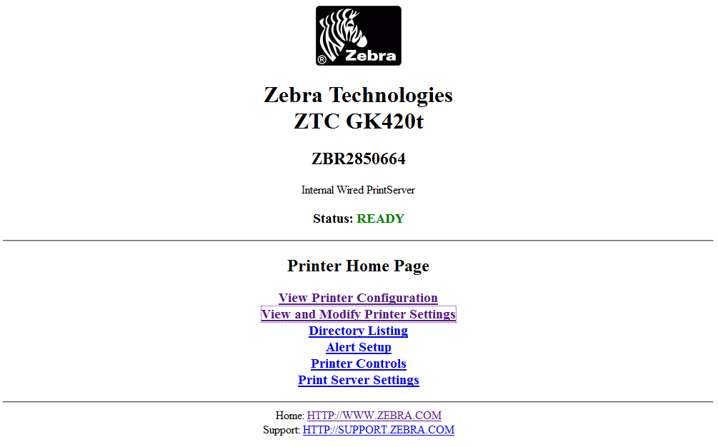
b). Click the link “View and Modify Printer Settings”
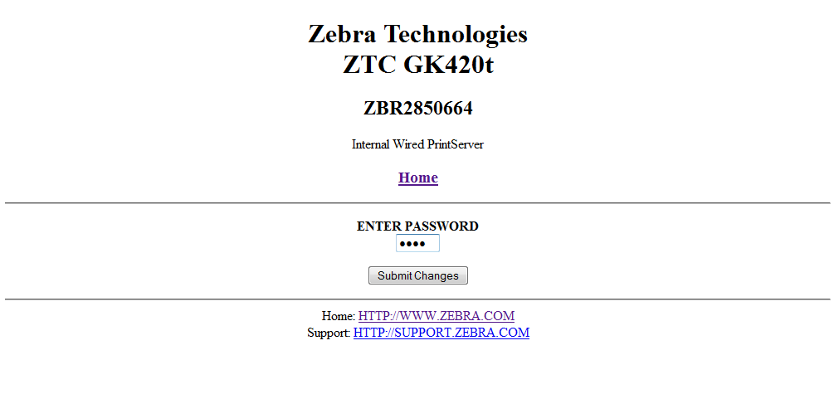
c). Enter the default password of “1234” and click “Submit Changes”

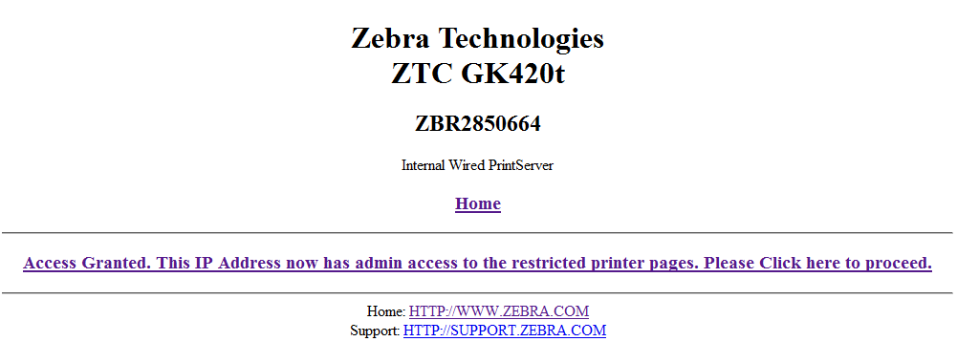
d). Click the link to “Access Granted…”
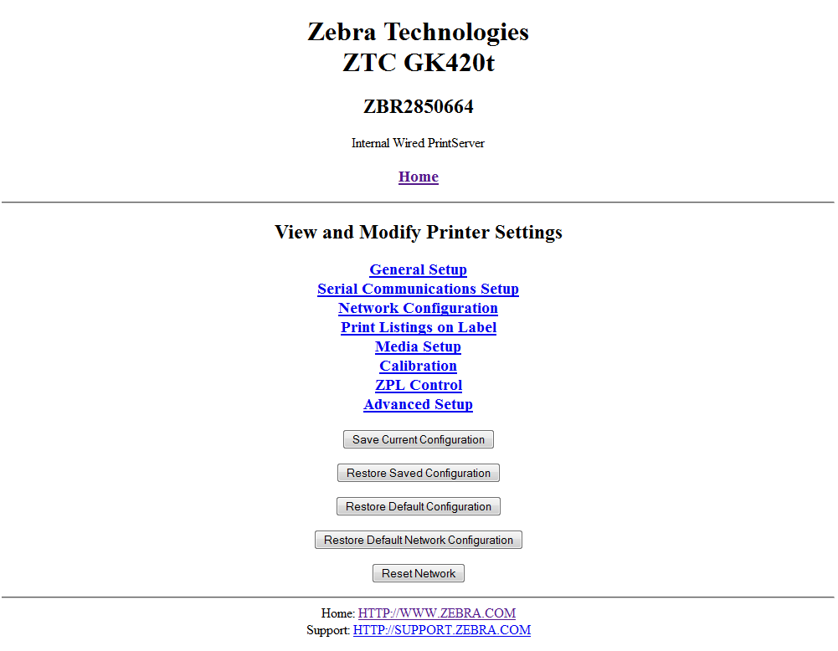
e). Click the link to “Network Configuration”
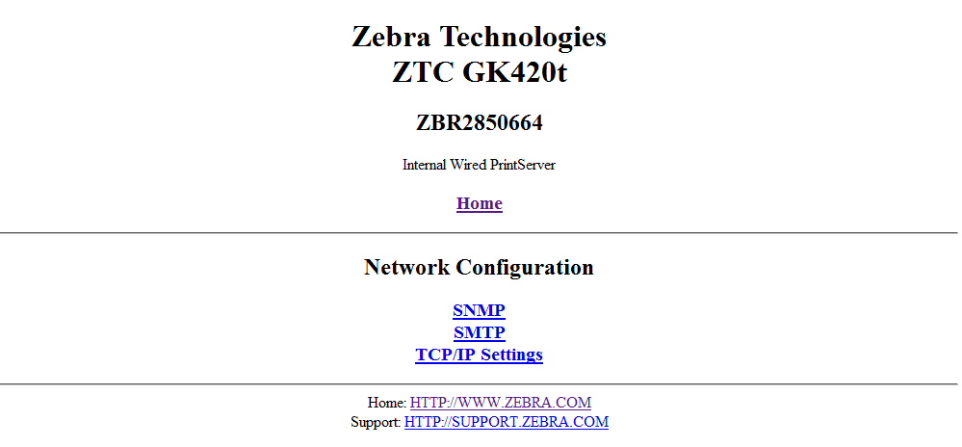
f). Click the link to “TCP/IP Settings”
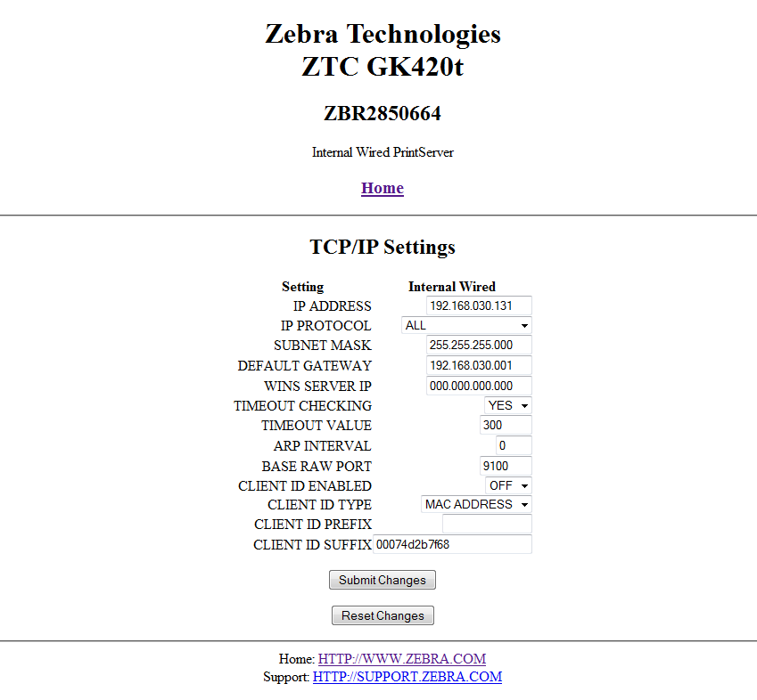
g). Set the network settings according to your local network policy. Typically this means to change the IP allocation to a “Static IP Address”.
h). When changes are complete, click “Submit Changes”
5). Configure the Gk420t Media Settings
a). Click the “Home” link
Open a web browser and browse to http://xxx.xxx.xxx.xxx (where xxx.xxx.xxx.xxx is the IP address of the printer).
b). Click “View and Modify Printer Settings”
c). Click “Media Setup”
d). Set the correct media settings for the stock
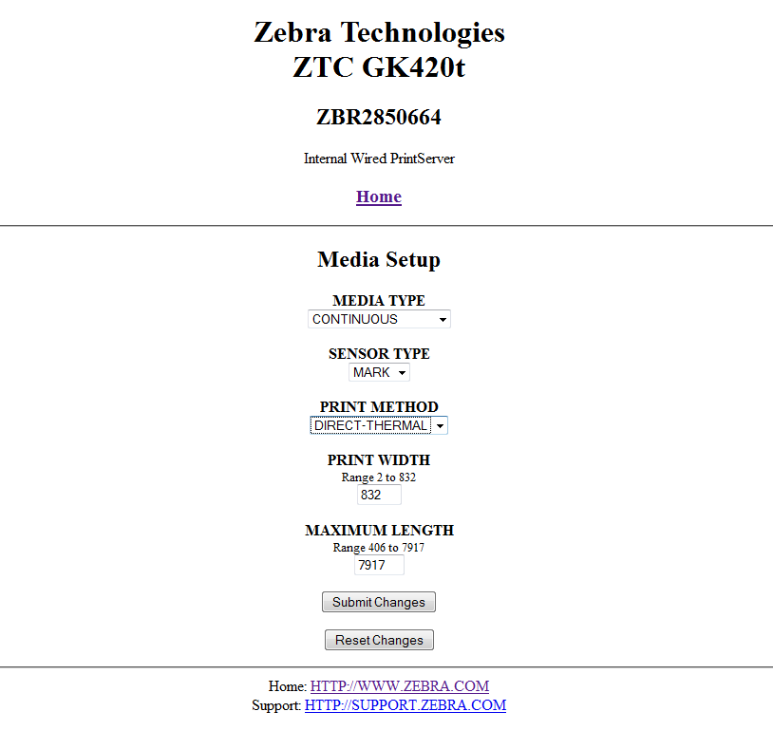
e). Click “Submit Changes”
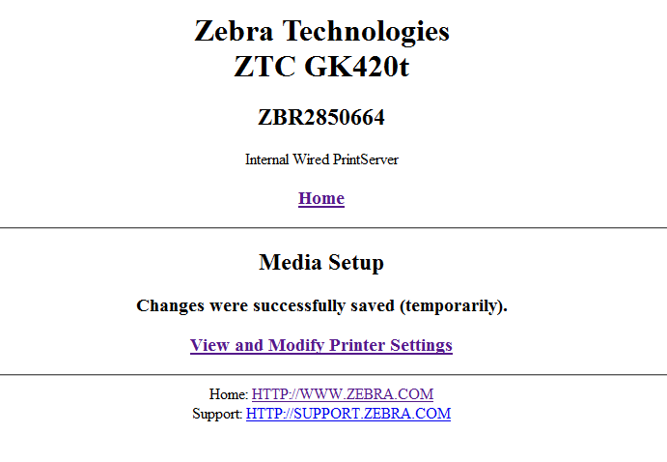
f). Finished

6). Install Zebra Setup Utilities (if not already installed)
Install printer setup utilities on any AIMS workstation that needs to print to the Gk420t. See “Zebra Setup Utilities Installation Instructions” for more details.
7). Install the Gk420t Printer driver
a). Run Zebra Setup Utilities by double clicking on the shortcut
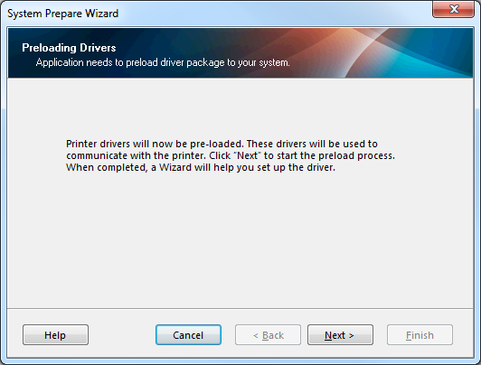
b). Click Next
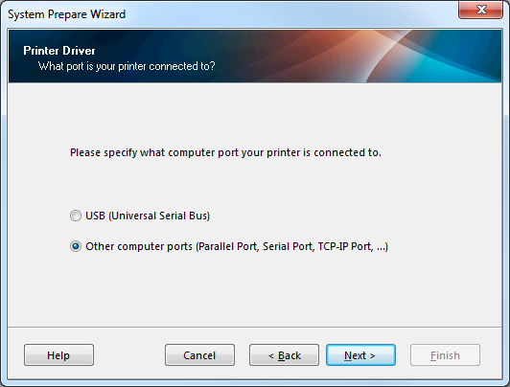
c). Select “Other computer ports…” and click Next
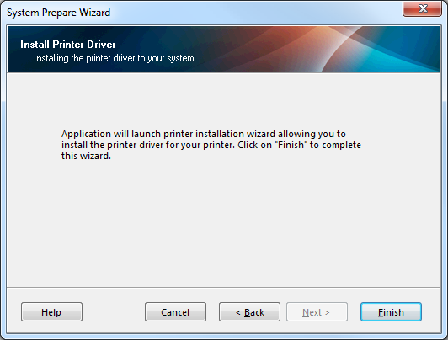
d). Click Finish
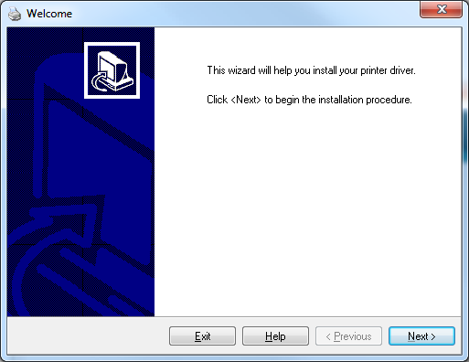
e). Click Next
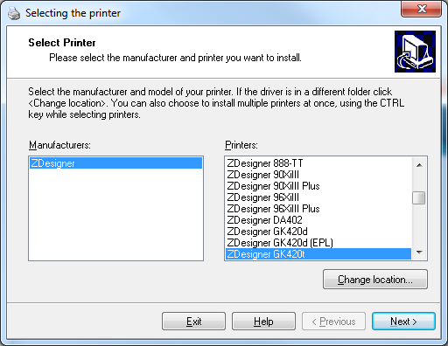
f). Select the GK420t and click Next
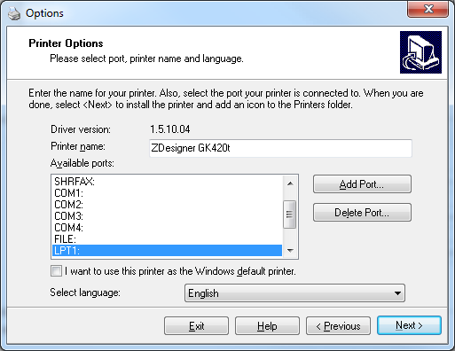
g). Click the “Add Port” button
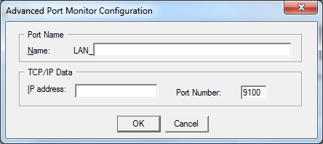
h). Enter the appropriate settings for your printer
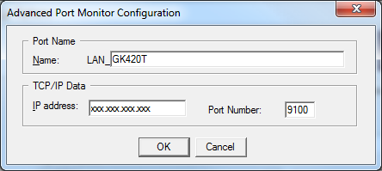
i). Click “OK” to continue
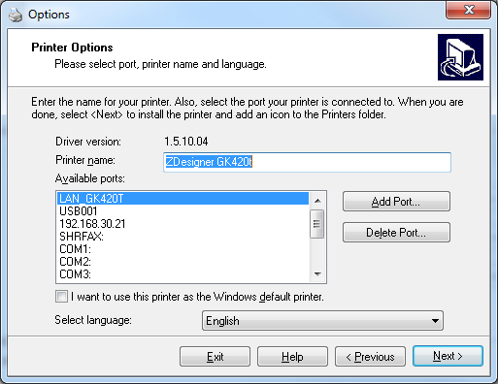
j). You should now see the new printer listed as an available port, click “Next” to continue
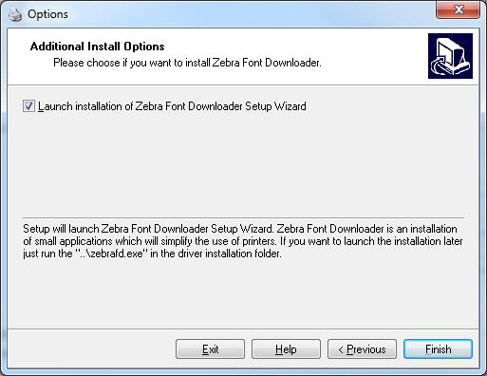
k). Click “Finish”
8). Configure the Gk420t Printer Settings
a). Run Zebra Setup Utilities by double clicking on the shortcut
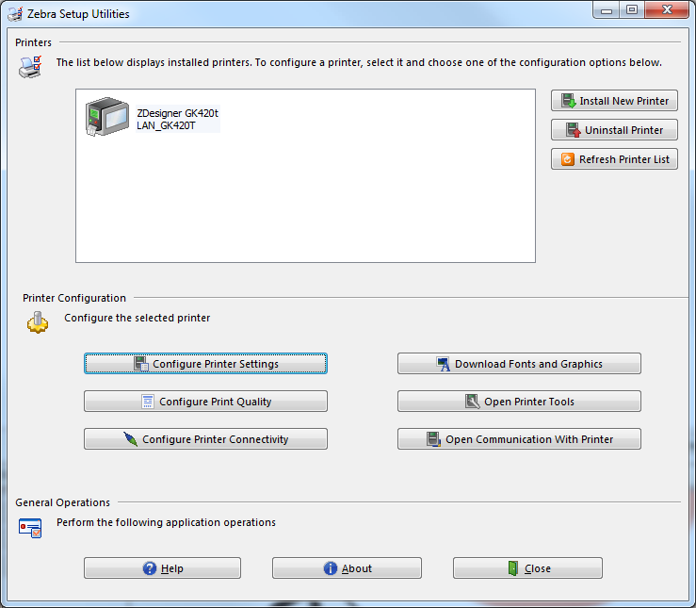
b). Select the Gk420t and click “Configure Printer Settings”
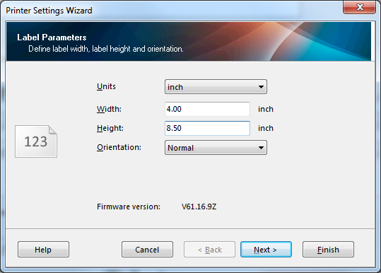
c). Enter the media size and click “Next”
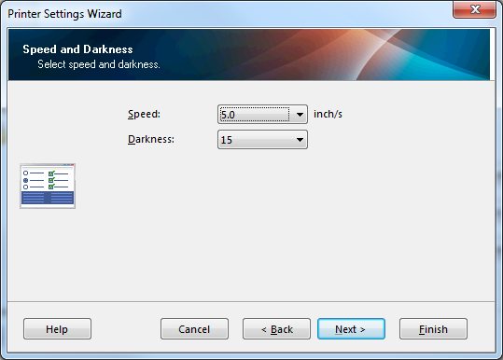
d). Leave the defaults, click “Next”
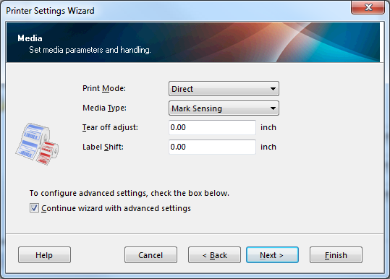
e). Set the print mode to “Direct” and the media type to “Mark Sensing”, click “Next”
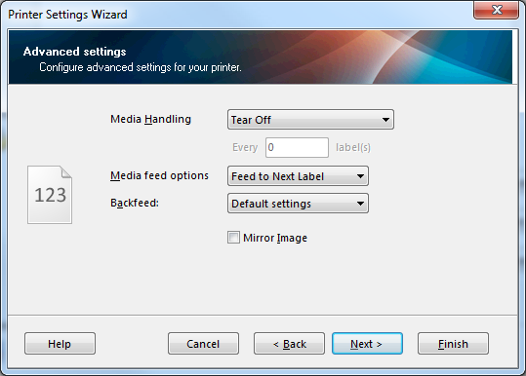
f). Click “Next”
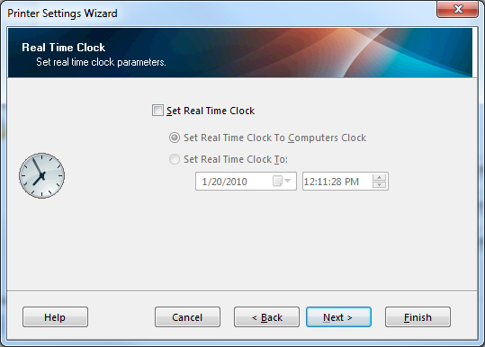
g). Click “Next”
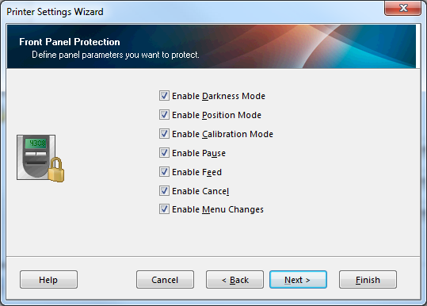
h). Click “Next”
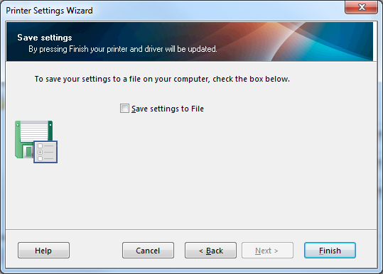
i). Click “Finish”

9). Configure AIMS for Printing
a). Log into AIMS, launch AIMS Admin
b). Click “Permits”, and then choose “Printing”
c). Setup the printer
i). Enter code and description
ii). Check the Active box
iii). Set the view order to “Default”
iv). Check all the relevant printer types
v). Set the printer name to the value provided in the Zebra Setup Utility
vi). Set the printer type to “Format File”
vii). Set the format to “GK420T Hangtag Default”
viii). Uncheck Preview and Edit
ix). Save
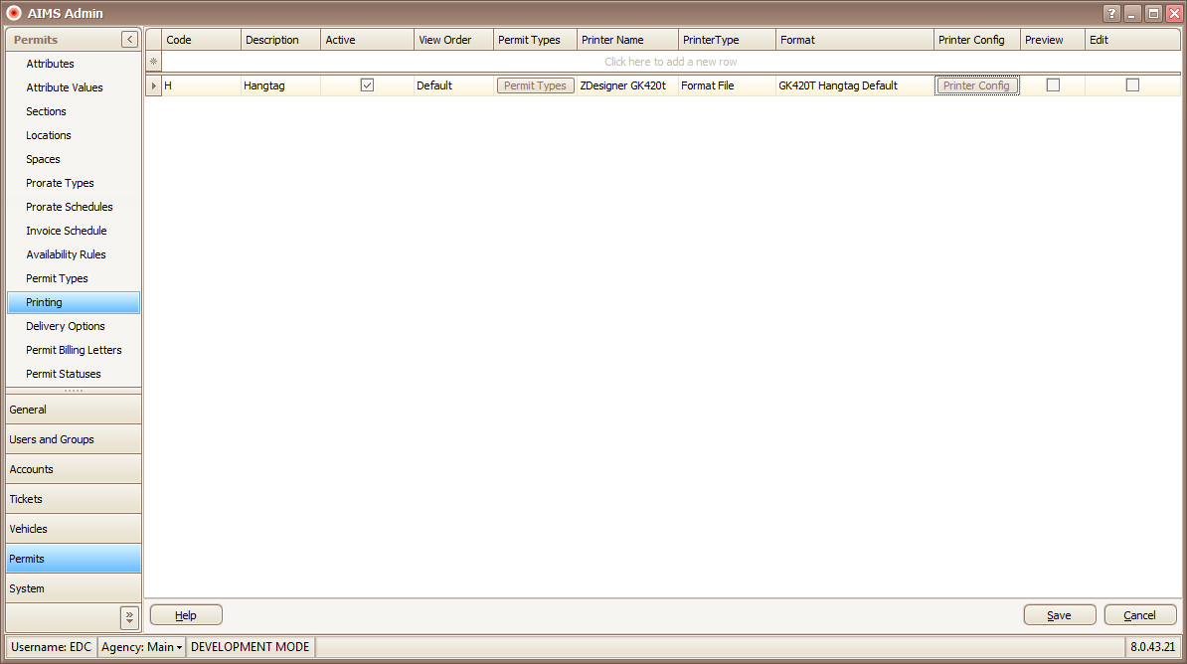
j). To test print, click “Printer Config” and choose “Test Print”
Troubleshooting
Problem: The printer starts printing at the wrong part of the hangtag
Solution #1: Verify that there is no tear offset configured within “Zebra Setup Utilities”, verify that the physical media has the stop bar in the correct place, if not adjust the tear offset accordingly.
Solution #2: Run the “calibrate media command”. To do this, open “Zebra Setup Utilities”, select the correct printer, click “Open Printer Tools”, click the “Action” tab, select “Calibrate media” and click “send”. The printer will print a series of blank hangtags and use its “eye” to locate the stop bar. When the process is finished, the printer paper feed light may blink, if it does press the paper feed button once.

