AIMS 9 Signature Capture  
 Installation Instructions

Prerequisites  
- Topaz SigLite Slim USB Signature Capture pad (Model T-S461-HSB-R)

- A PC (Windows 7 or later) with an available USB port  
- Software Driver:

- Download link: <http://www.aimsparking.com/pub/utils/AIMSIG/sigplusnet.exe>   
- AIMSIG Installer:

- Download link: <http://www.aimsparking.com/pub/utils/AIMSIG/AIMSIG.1.0.0.1.Setup.exe>

## Install Drivers

a. Login to the PC as a workstation Administrator

b. Install the software driver from above (sigplusnet.exe). This is the capture pad driver. As follows:

i. Click Next  
 ii. Do not change the default destination. Click Next  
 iii. Click OK  
 iv. Select “T-S”. Click OK

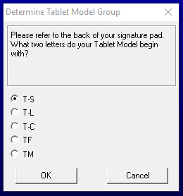

v. Select “T-S461”. Click OK

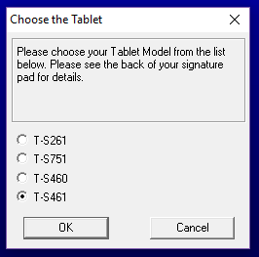

vi. Select “HSB (USB type)”. Click OK.

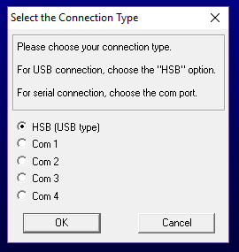

vii. Click Agree.  
viii. Wait a moment while software installs, then click Finish.

c. Install the AIMSIG, Signature Capture component: AIMSIG.1.0.0.1.Setup.exe. Install into the same directory where AIMS is installed.

d. Plug the Topaz SigLite Slim into the PC’s available USB port. Nothing will appear to happen, but the device will be ready for use.

## AIMS Setup

1) Login to the AIMS Admin

2) Under the General section, click on Report Templates

3) Expand the Category: Quickletter by clicking the +

4) For the Quickletter that will have a signature, check the Signature check box

5) Click Save on the bottom right

6) Right click on the letter and select Edit Template

7) Enter in the criteria and click OK

8) Add a Picture Box field where you would like the signature to go

9) From the Field List, under report_settings set the new Picture Box field to use the signature field. Use the “Zoom Image” size option so the signature will scale to the size of the field.

10) After making the modifications, Save the Quickletter.

11) To test the signature, generate the Quickletter in AIMS. It should open the Signature Capture dialog first, and once that is filled in the letter will open.

## Troubleshooting

- Ensure the signature pad is plugged in.

- The signature will be displayed on the computer screen and not on the pad. This is normal behavior—the signature pad does not have display capabilities.

- You can run the program outside of AIMS for testing. Red text will show indicating the program is in test mode and will prompt you for a destination to save the file to.   
 - Enter and save a signature.  
 - Verify that the signature file saved is accurate.